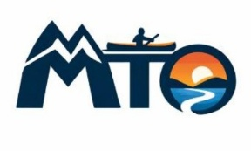
Expedition Kit List

Below is a recommended kit list for the expeditions that Mountains to Oceans (MTO) run. This is a list of essential items that enable participants to be as comfortable as possible whilst on our trips. MTO are unable to provide sleeping equipment such as tents, sleeping bags or sleeping pads. We provide the technical equipment such as 16ft expedition rigged canoes, appropriate personal flotation devices, paddles and, if necessary, helmets. We also provide a 60-litre dry bag/barrel to keep your personal equipment dry. We are happy to offer recommendations on what equipment will work best for our trips so just ask!

Waterproof jacket
Waterproof trousers
Base Layers (t-shirt, long sleeve shirt)
Thermals (trousers, long sleeve top)
Outdoor quick dry trousers
Jumper
Underwear
Socks
Sun hat
Woolly / bobble hat
Gloves
Tent appropriate for expedition use.
Sleeping bag, Minimum 3 season.
Sleeping matt
Personal small dry bags
Bug Repellent
Bug Net
Sun Screen
Appropriate paddling footwear such as
lace-up trainers / shoes.
(Not crocks or flip flops or slip on shoes.)
Evening footwear (Crocks, flip flops)

